DataBase:- Database is a Collection of related /Interrelated Data.

Ex:- Bank DataBase.

Hospital Database.

University Database.

c.1) Classification of Database:- The Databases can be classified as follows:

I)Based On Number of Users:

a)Single User Database:- A single user database supports only one user at at time. A single user database that runs on personal computer is called ‘personal or desktop Database’.

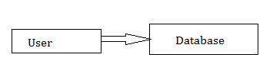

b)MultiUser Database:- A multi user database supports multiple users at the same time. When the multi user database supports few users(less than 50) then it is called ‘workgroup database’. When the database supports many users(more than 50) then it is called‘Enter prise Database’.

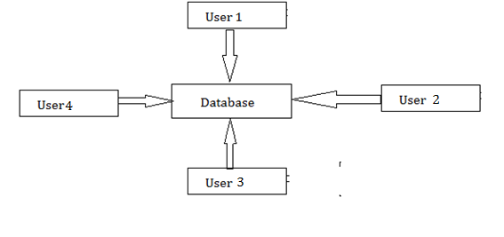

II) Based On Location:

a)Centralized Database:A Database which is located and stored in single location is called ‘centralized Database’. The centralized database location is generally desktop or main frame computer which is accessed by users through computer network like LAN or WAN.

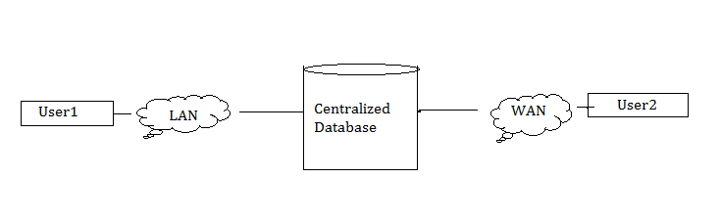

b)Distributed Database:- A distributed database represents multiple interconnected databases spread out across several sites(locations) connected by network. Since the databases are all connected, they appear as single database to users.

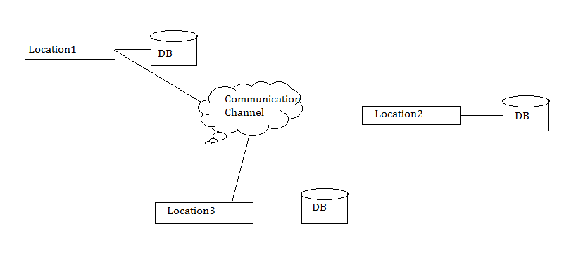

III)Based on Data Usage:

a)Operational Database: A database that is designed to support a company’s day-to-day operations is called an operational database. It is also called transactional or production database.

The Operational Database management system is software .

Example to Operational DBMs is ERP(Enterprise Resource Planning).

b)Data Warehouse: A data warehouse is large storage space. It collects the data from various sources or locations.